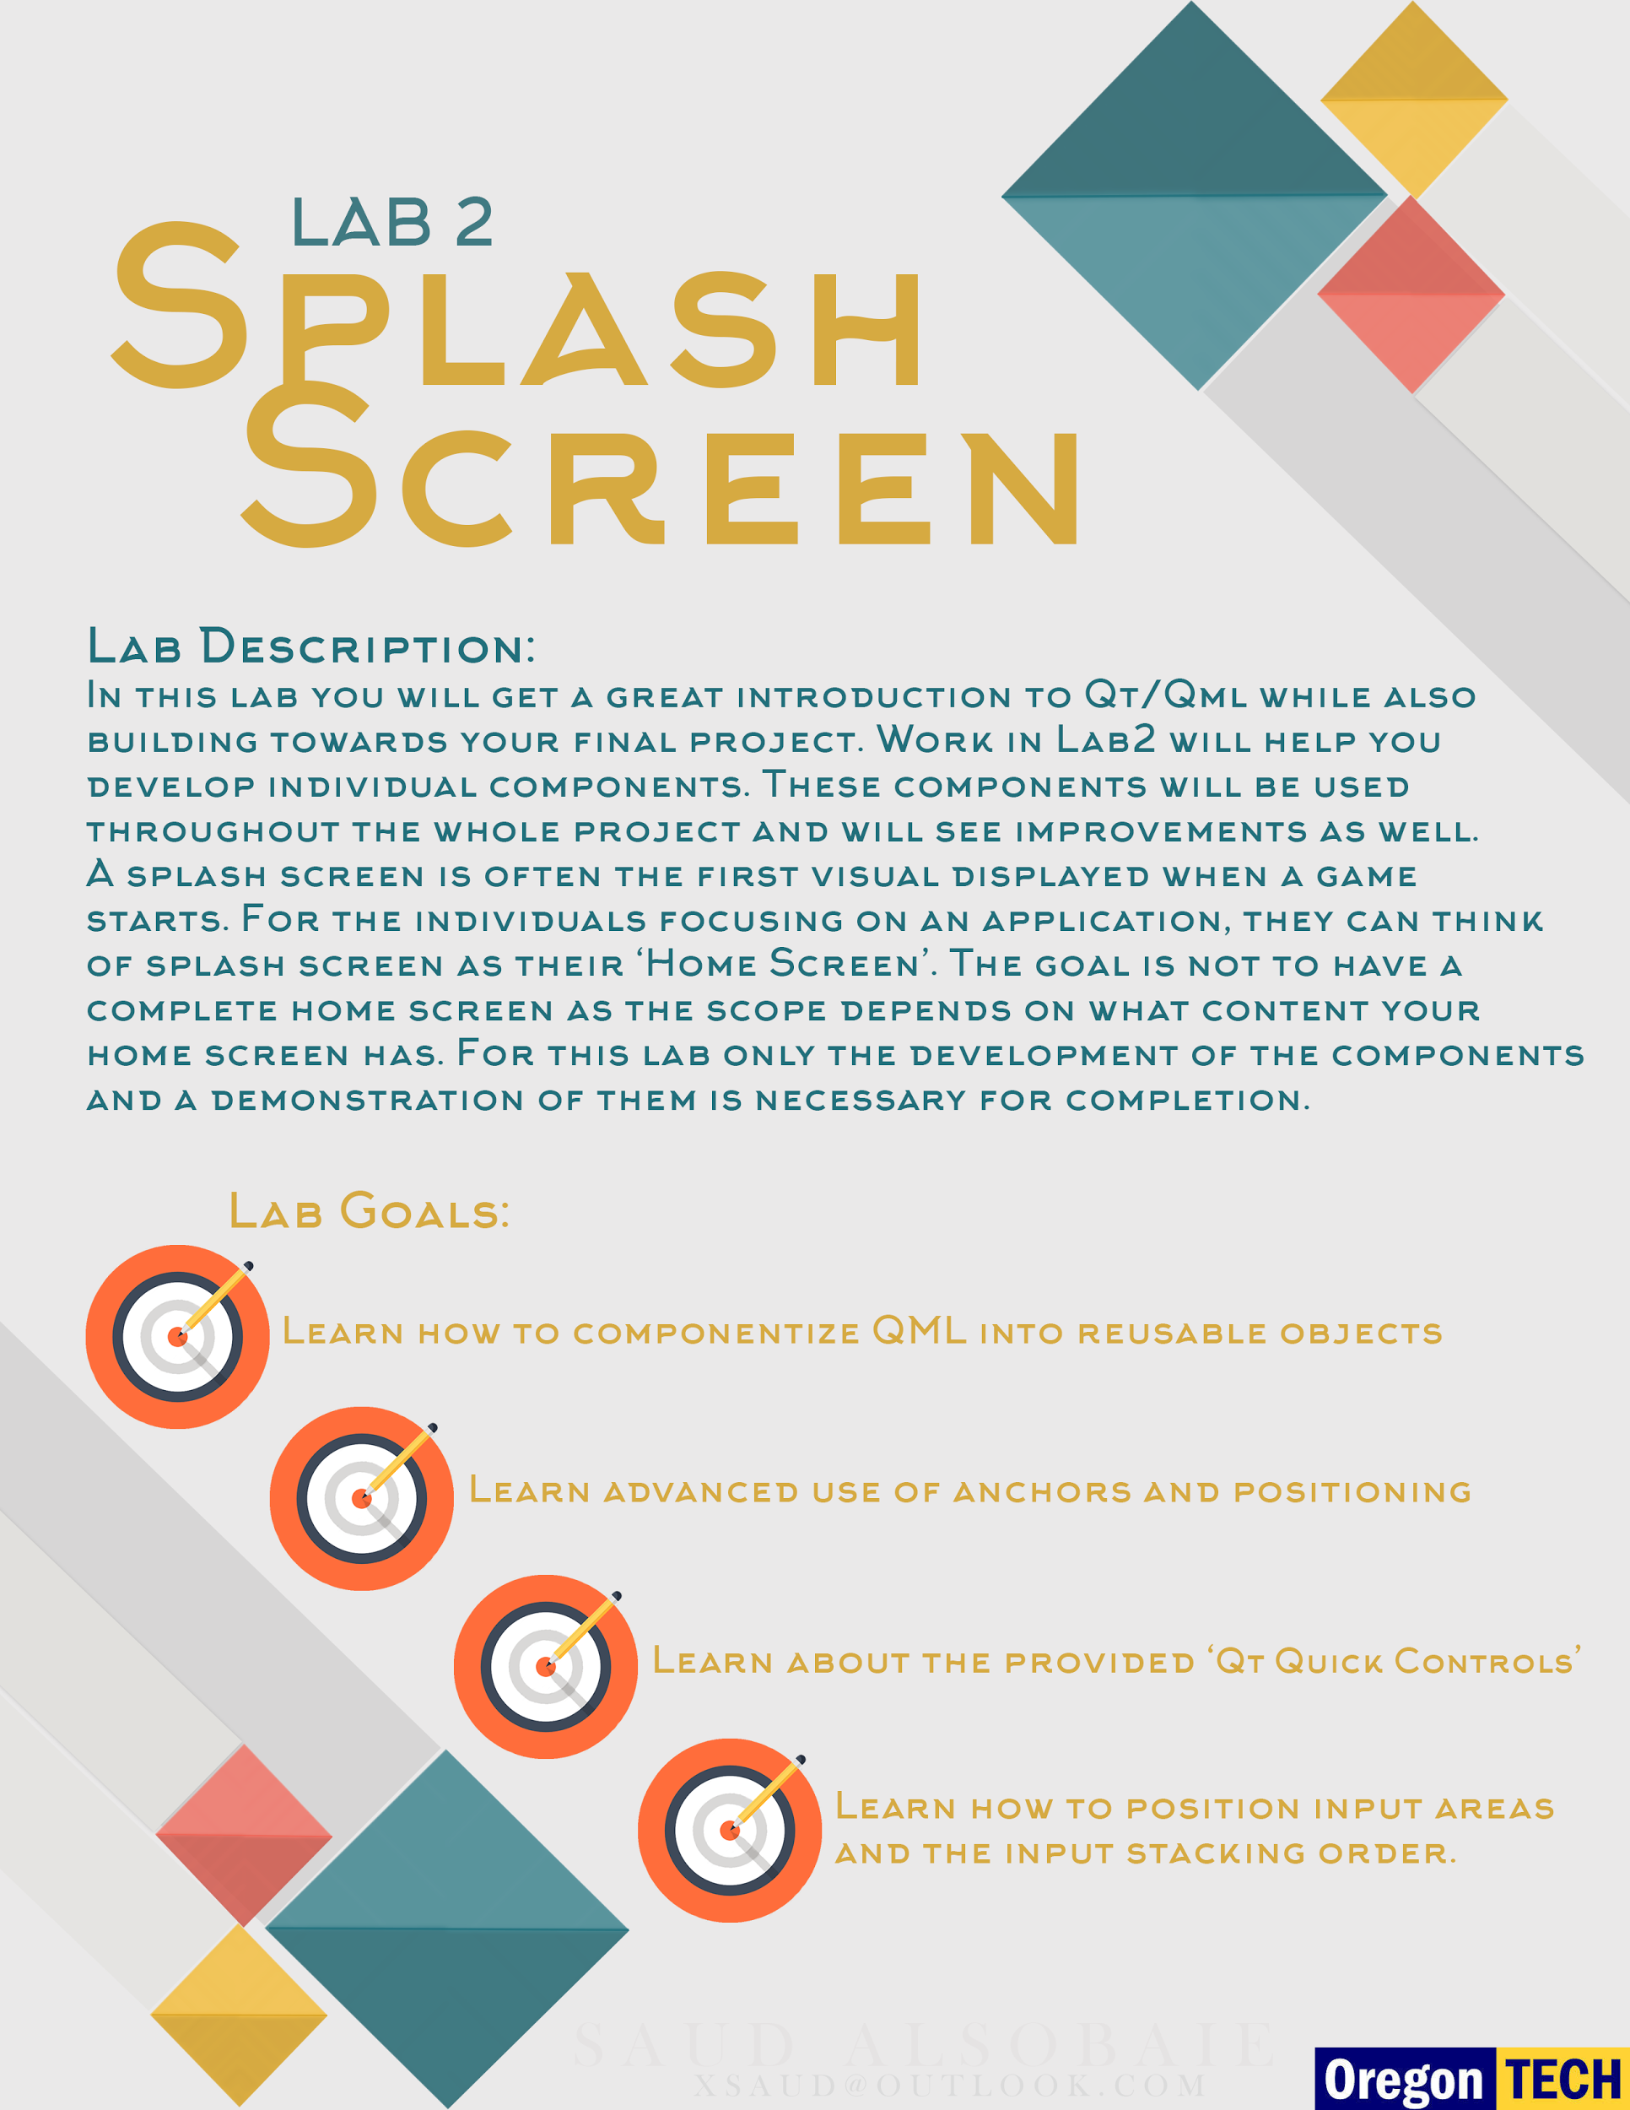

***CST 238: Graphical User Interfaces***

**Lab 2: Appendix A Beginning Your Project**

* **READ EACH STEP CAREFULLY -**

**Create your project in QtCreator:**

Follow the steps below to create a **Qt Quick Project**

**(from)** <http://doc.qt.io/qtcreator/quick-projects.html>

1. Select **File** > **New File or Project** > **Application** > **Qt Quick Application** or **Qt Quick Controls Application** > **Choose**.
2. In the **Minimal required Qt version** field, select the Qt version to develop with. The Qt version determines the Qt Quick imports that are used in the QML files. Select the highest version available (5.6).
3. Uncheck “**With .ui.qml file“.** Using the Qt Designer will not be covered in this course. Students are welcome to use it but we encourage you write all code yourself. Inserting code with “drag-and-drop” tools only furthers you from what is actually happening.
4. Select [kits](http://doc.qt.io/qtcreator/creator-glossary.html#glossary-buildandrun-kit) for running and building your project, and then click **Next**.
5. Review the project settings, and click **Finish** (on Windows and Linux) or **Done** (on OS X) to create the project.

You now will have an empty project with a mouse and text area. ***Delete*** the mouse and text areas so your main.qml only has a **Window** object.

Now at the top of main.qml add a file header comment with the following items.

**Name:** (your name here)

**Lab:** (number and lab name)

**Project Name:** (project name here)

***CST 238: Graphical User Interfaces***

**Lab 2: Appendix B Creating Base Components**

**Build 3 Base Components:**

Create a **Button**, **TextRect**, and **Dialog** component.

**Button**: The button is a basic widget that combines a [MouseArea](http://doc.qt.io/qt-5/qml-qtquick-mousearea.html) and a [Rectangle](http://doc.qt.io/qt-5/qml-qtquick-rectangle.html) to form a single object to handle drawing and user input. Location of the MouseArea is important because visually (and through training) the user expects the entire button region to accept the mouse click. (See Below)  
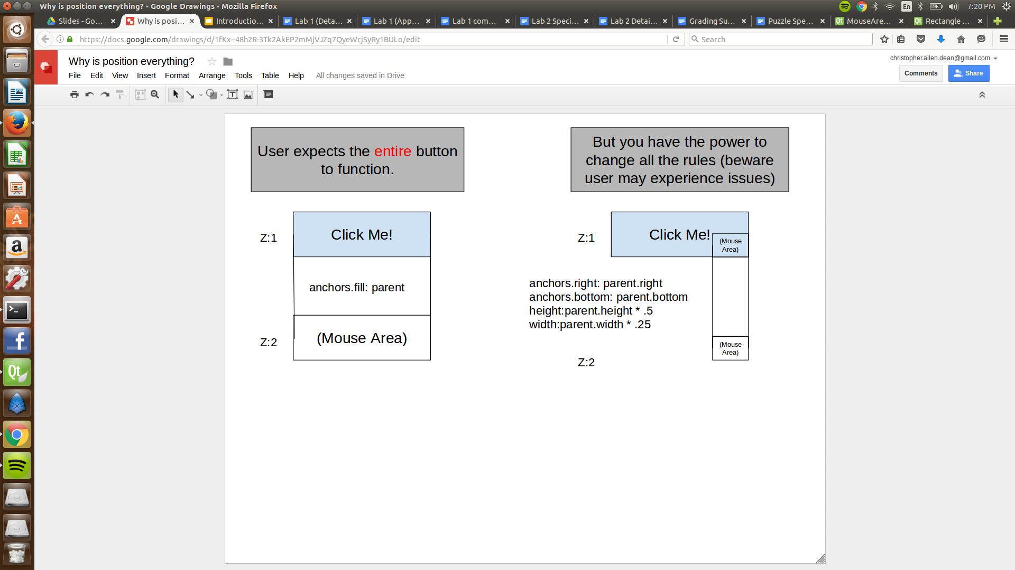

The button should have the following [signals](http://doc.qt.io/qt-5/qtqml-syntax-signals.html) exposed at minimum.

* onClicked
* onHoverStarted (Create from existing hover events)
* onHoverFinished (Create from existing hover events)

This component will be used by the rest of the team so think about consumer vs producer responsibilities. Developers should be able to use your button like: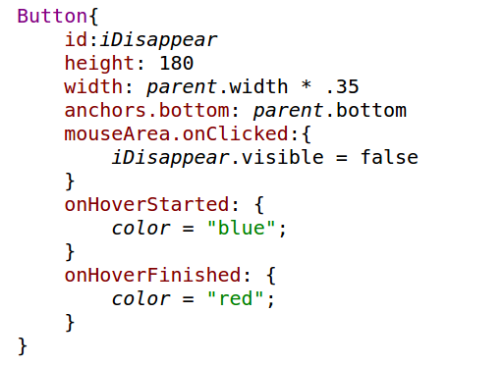

***CST 238: Graphical User Interfaces***

**Lab 2: Appendix B Creating Base Components**

**Build 3 Base Components (continued):  
TextRect:** The TextRect will pair a [Text](http://doc.qt.io/qt-5/qml-qtquick-text.html) object and and Rectangle to create a widget to display text information to the user. The message should not be hardcoded into the TextRect. The idea of building components is to be reusable. Engineer a reusable component that can display text like: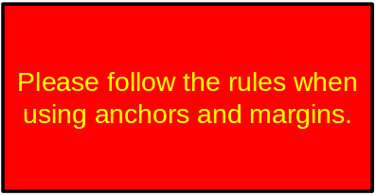

The TextRect should have external properties to set what *text* is displayed, what *color* the background is, and the *font* properties (use an [**alias**](http://doc.qt.io/qt-5/qtqml-syntax-objectattributes.html)).

***CST 238: Graphical User Interfaces***

**Lab 2: Appendix B Creating Base Components**

**Build 3 Base Components (continued):**

**Dialog:** The Dialog object pairs the Button and the TextRect object together to create a dialog widget. Similar to the button think about how the consumer of Dialog object will expect them to work. How will the Developer know when internal buttons are clicked? The Dialog should be [draggable](http://doc.qt.io/qt-5/qml-qtquick-mousearea.html#drag-prop) when clicking on the inside of the rectangle. You should be able to drag the dialog around the application. It is ok to not have the button inside the Dialog component.

All three of these components should be as modular as possible (large chunks should be broken into smaller components). Use your best judgment. In general follow the rules below.

**Rules for Building Components**:

* Reference **ONLY** **id**s declared *internally*. (NO Spaghetti code)
* When building new components often change the base ‘**Item**’ to a **Rectangle** instead (adds visual properties).
* When changing scope (working inside of a component) think about that component only. Not the other things in the scene. But instead think about all items relevant to the parent item (of the component).
* Have a big picture in mind of the relationship between Components.

***CST 238: Graphical User Interfaces***

**Lab 2: Appendix C Creating Splash Screen**

**Create your splash screen/home screen :**

The code for your splash screen can be written in main.qml. But following the component rules above it might be good to build a SplashScreen/HomeScreen object.

Your screen should have 2 dialogs. One will be hidden behind the other (use Z stacking order or visibility property).

The dialog should contain:

* Some sort of introduction to your project - **be creative**.
* A Button that moves along a conversation or just changes text.
* Behind the dialog will be a smaller dialog that says “Hello from, (Your Name)”.
* On the smaller dialog, the button labeled ‘Goodbye’ will close the application when clicked. 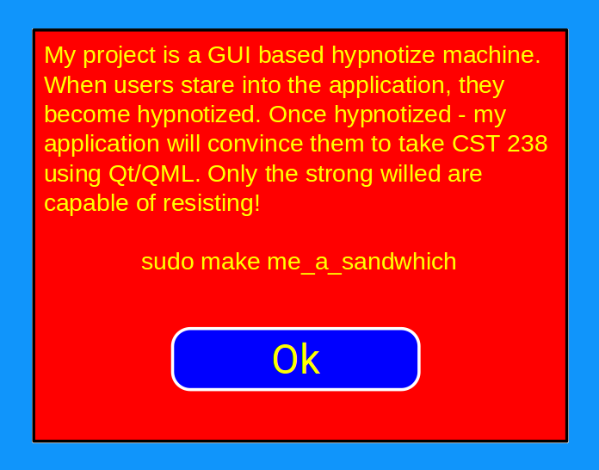

***CST 238: Graphical User Interfaces***

**Lab 2: Appendix D Rubric**

**70 percent of this lab is meeting the requirements. The other 30 are based on demonstrating the lessons shown in class and found in the Qmlbook.**

**Points will be given out as follows:**

**Components** (All three components created and used)  **70%**

**Appropriate use of**: (**0**= None, **1** = Good, **2** = Great)  **10%**

* Id’s (respect of encapsulation) & Aliases (2%)
* Events (x3): onClicked, onHoverStarted (2%)
* Anchors to position buttons,

and z-index (stacking can be implicit) (2%)

* Text and font properties (styling) (2%)
* Background Image loaded (separate qrc) (2%)

**Structure and Clarity of Qml** (respect shared | difference) **10%**

**Creativity** **10%**

Total  **100% (600 points)**

**Optional**: Extra Credit to anyone that provides extra features like animation, multimedia or sound effects.

**Example of an “A” Splash Screen:**

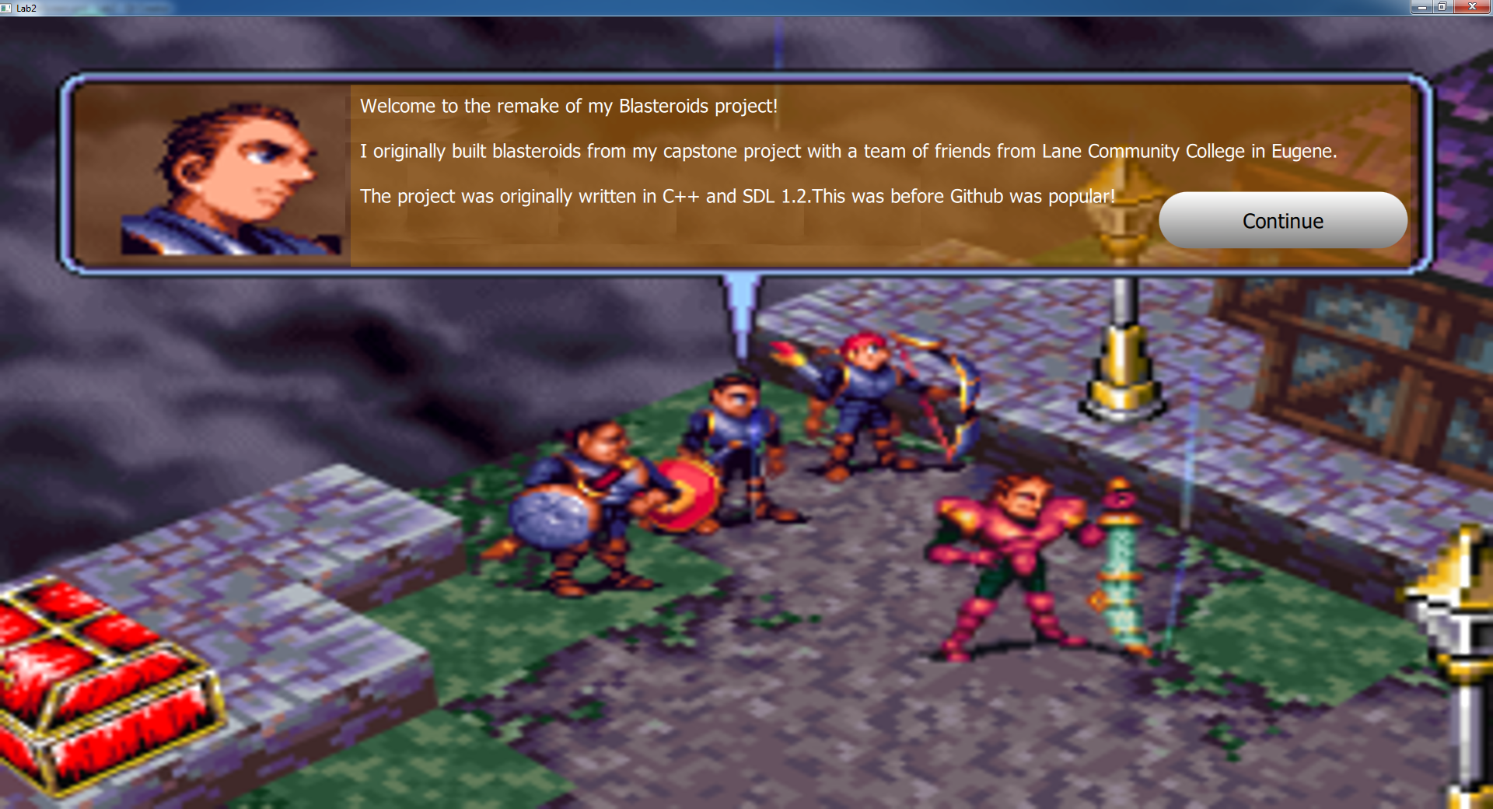Why an A? All three components exist. All three components are used to creatively build the beginning of the user’s project. The button animates to the user’s input. The user used property bindings and aliasing to build reusable components.

**Example of a “B” Splash Screen:**  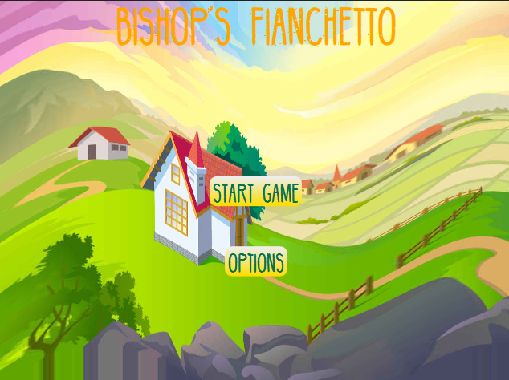

Why only a B? No dialogs, buttons and textrect non-existant (did not break down into components) and nothing is draggable.

**Example of a “C” Splash Screen:**

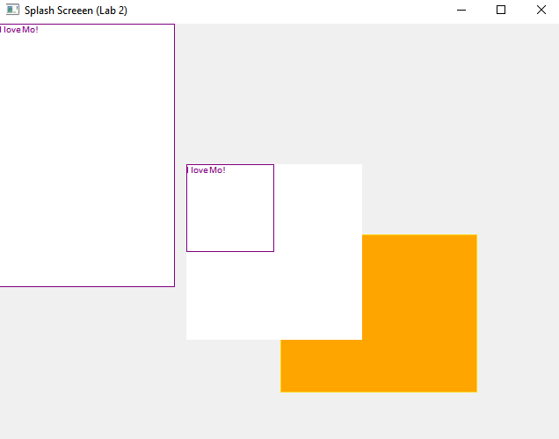

Why? Meets most of the requirements, but as you can see...looks terrible. Zero creativity, button positioning doesn’t make sense, no labels, no multiple dialogs (not stacking order)...this is basically as bad as you can get while still meeting most of the requirements. Obvious visual glitches.